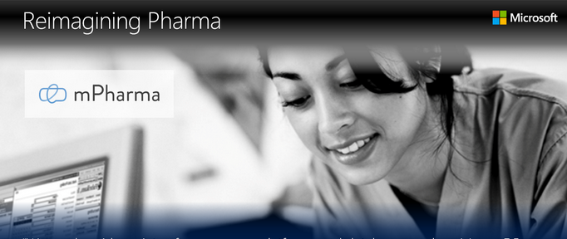
“The IMS Institute estimates that pharmaceutical spending in Africa will reach US$45 billion by 2020. However, the lack of comprehensive data on pharmaceutical consumption makes it difficult for governments and pharmaceutical companies to gain market intelligence on medicine use.”
This is The Problem that mPharma set out to solve.
Their intended solution is best described in their Vision, which is “to provide patients and caregivers access to high quality medicines and information, while enabling health ministries and pharmaceutical companies to obtain real-time pharmaceutical and health information.”
To achieve this, mPharma set out three primary goals:
- Delivering paperless prescription services to automate and thereby dramatically improve the process of prescribing, locating and obtaining needed drugs.
- Providing real-time health monitoring of adverse drug reactions by leveraging simple message service (SMS) technology, which is already widely used in Africa.
- Giving governments, hospitals, doctors and pharmacies subscription-based access to real-time anonymous drug consumption and diagnostic market analysis services.

Microsoft accelerates fulfillment of the vision
Achieving these goals would require not only financial support, but also technological and business process support. mPharma applied to the Microsoft Ventures Accelerator Program to obtain this support. For promising, early-stage start-ups or first-time entrepreneurs, Microsoft Accelerators are immersive programs aimed at “squeezing the countdown to launch” and “creating great businesses at breakneck pace.”
Participants receive four months of intense mentoring, technical guidance and connections to other start-ups. They are also onboarded onto Microsoft Azure and receive US$5,000 worth of Azure services per month for their first year of operations. Once the start-up ball is rolling, participating start-ups are introduced to global seed funds that offer them the opportunity to receive strategic investments that can propel their business to the next level. Currently, about 80% of the over 200 start-ups graduating the program have been awarded funding averaging US$1.5 million in the first round.
“One of our board members was actually a mentor in the Accelerator program,” explains mPharma co-founder and CEO Gregory Rockson. “We had already begun at that time to develop our solutions and realized that the research and other resources available in a program like the Accelerator would be very valuable. So we applied immediately.” mPharma was one of only eleven applicants accepted.

Improving healthcare through pharmaceutical lifecycle tracking
mPharma’s solution begins in the doctor’s office when they prescribe medication. These prescriptions used to be written on paper. Patients would then attempt to fill the prescription; often finding it unavailable at the pharmacies they visited. Once they did find it and obtain it, the flow of information ended.
Doctors now enter prescriptions into the Azure cloud-accessible mPharma database, which informs patients about the nearest pharmacy that has their medication in stock. mPharma provides a plug-in for the pharmacies to which they can link their inventory information systems. Once a medication has been prescribed, the patient receives a code via SMS. The code can be received on any mobile phone. Patients do not have to have a smartphone!
Patients subsequently report their use of the medication and any adverse reactions via SMS as well. The individual data can be used by the doctor for follow-up, and the aggregated data is then used anonymously to provide real-time utilization data that governments, hospitals and pharmacies use to learn more about doctors’ prescription practices, patient usage and other patterns important for better management of healthcare delivery.
“Let’s say a company like Novartis wants to introduce a new malaria drug into a country like Zambia,” explains Rockson. “They can use our data to help them pinpoint where in-country the drug is most needed and then track how well that drug performed!”

Azure an ideal platform for open source development
There are many applications required to connect mPharma to the doctors who write the prescriptions, the pharmacies that fill them, the patients reporting any drug interactions or other adverse effects and the government and pharmaceutical providers that use the reporting. To accomplish this, the mPharma development team leveraged a wide variety of open source platforms, databases and other software engines: including MongoDB, PostgreSQL, Django, Redis, RabbitMQ, Angular.js and Node.js. These also included Linux distributions such as Ubuntu for their node server and CentOS for their database server.
“We have yet to run into any issues with Azure,” remarks mPharma Chief Technical Officer James Finucane, “and it tends to perform as well or better than other solutions we have tried!”

