CORE Construction

Construction Company Builds Global View into Project Management with New Tool

Share
July 07, 2014
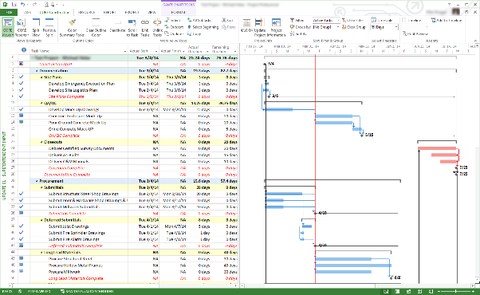
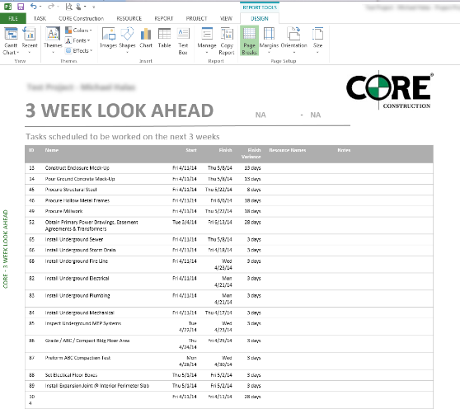

CORE Construction wanted to standardize on a user-friendly tool to manage its construction projects’ schedules, and executive staff needed better insight into the company’s US$700 million project portfolio. It achieved these goals with Microsoft Project Server 2013, building a reporting solution that automates the publication of project data to an online dashboard. Now, executives can make timely decisions to ensure a project finishes on time and on budget.

Situation
CORE Construction differentiates itself from competitors through its attention to detail and unstinting customer service. “We take care of our customers by finishing their construction projects on time and on budget,” says Dustin Burks, Chief Information Officer at CORE Construction. “It’s a critical part of our success. If a project runs over schedule, we see the profit fade significantly.”
With more than US$700 million worth of projects running in any given year, CORE Construction faces a significant challenge in ensuring that schedules are met. “The schedule is one of the most important things that we measure on our projects,” says Burks. “We have approximately 200 project managers, assistant project managers, and field superintendents on job sites. Our project managers build jobs according to their schedules and report on progress to management and to customers.”
CORE Construction used different versions of project management and scheduling software from Oracle. With inconsistent tools, it could not define a standard approach to project scheduling and reporting. Management had limited visibility into the company’s project portfolio, relying instead on verbal reports or individual project schedules that were not always up-to-date. In CORE Construction’s experience, the Oracle tools did not work well with the company’s enterprise resource planning (ERP) solution or its intranet, which is built on Microsoft SharePoint technologies.
“This was frustrating because project managers wasted time manually entering schedule updates into the ERP system. We also wanted to make a project portfolio dashboard available for our executives on our intranet,” says Burks. “So last year when we began looking at ways to introduce streamlined, consistent business processes, a new project scheduling solution became a top priority.”

Solution
CORE Construction gained a cost-effective, user-friendly, and interoperable project portfolio management solution with Microsoft Project Server 2013. CORE Construction made its decision after evaluating the pros and cons of standardizing on the latest solution from Oracle.
“Oracle was too expensive, and we would still have the interoperability issue,” says Burks. “Project Server 2013 is built on Microsoft SharePoint Server 2013 and interoperates with our ERP solution and the SharePoint Online and Lync Online services that we get with our subscription to Microsoft Office 365. Also, we could see that the user interface for Microsoft Project Professional 2013 was very intuitive.”
CORE Construction worked with Sensei Project Solutions, a member of the Microsoft Partner Network, to deploy more instances of Microsoft Project Professional 2013. Employees used the desktop software to track project schedules and report on milestones, but when Sensei demonstrated that Project Server 2013 could deliver a global view into its project portfolio, CORE Construction decided to deploy the server-based solution as well. Project Server comes with Microsoft Project Web App, a web-based application that CORE Construction employees can use for many project management tasks, anywhere they have an Internet connection.
Along with SharePoint Online, CORE Construction has an on-premises installation of SharePoint Server 2013. It envisioned using Project Server 2013 to automatically update project data into the ERP solution, which could then feed that data into the on-premises SharePoint Server solution. From there, current project data could be published on a new project portfolio dashboard, hosted on SharePoint Online.
“The team from Sensei Project Solutions was terrific,” says Burks. “They provided tremendous value as they unlocked the potential of the software. We went from the client-only deployment to the full project portfolio solution in less than three weeks.”

Benefits
Using its project portfolio management solution from Microsoft, CORE Construction has a user-friendly tool to ensure project schedules are met and to enjoy anytime, anywhere access to project data. At the same time, executives have new visibility into the project portfolio. “With Project Server 2013, we gain easy access to consolidated, standardized, and accurate project and portfolio data,” says Burks. “Now we can ensure that our projects are completed on time and our customers are satisfied.”

Reduces Costs
CORE Construction saved Oracle licensing costs by choosing Microsoft Project Server 2013. “The real cost reduction is in the increased visibility that allows us to proactively address problems with the project schedules before the issues turn into costly delays,” says Burks. “We are also saving labor costs because our project managers no longer have to manually enter data into our ERP system.”

Enhances Data Accuracy
Because the dashboard publishes consistent, consolidated project data, reporting is more accurate and efficient. Management has better insight into the company’s global health at any moment in time. “Our information is also more accurate and up-to-date. When someone updates a project schedule, it’s reflected in the dashboard in near real time, so we have immediate transparency into what’s happening.” (Figure 2.)

Improves Profit Margins
CORE Construction management staff can quickly make the best decisions to ensure each project’s profitability because it has better access to project schedule data. During their weekly management meetings, staff members can use Project Web App to look at the dashboard and evaluate the status of key milestones.
“If something looks amiss, we can drill into specific schedules to take corrective action before we lose that project’s profitability,” says Burks. “Improved visibility into projects’ schedules means we can make good decisions to ensure we finish our projects on time, which provides significant value to us and our clients.”

